Writing DAX Queries in DAX-studio
Indhold
Writing DAX Queries in DAX-studio 1
Connecting to Power BI Desktop​ 1
Basic Queries​ 3
So you can run EVALUATE Customer to output all the rows in the customer table 3
EVALUATE VALUES ( Customer[City] ) returns column, værdier fra Customer[City] 4
CALCULATETABLE() , use to only return rows that meet a given criteria. 4
Return value :A table of values 5
DATATABLE Function in DAX : a way to declare an inline set of data values 6
DEFINE VAR VarName=.. 6
SELECTCOLUMNS(<Table>, [<Name>], <Expression>, [<Name>], …) 7
CALCULATE(<expression>[, <filter1> [, <filter2> [, …]]]) 7
TREATAS meget stærkt værktøj 7
Sorting Results​ 8
Adding Calculations​, a measure 8
Aggregering over month, som tabeludtræk vha Revenue-measure, implicit tabel-join 8
Returning a single value​ 10
SUMX(ColumnName) og SUM(Table,expression(row)) 11
Selecting columns from multiple tables​, med implicit join 11
//Sales and Date joines implicit: finder salg/år 11
Multiple Resultsets​ 12
Using Parameters in Queries​ 14
Web-course 15
Create new column in table 16
//sum af kolonne-værdier 18
Lave permanent tabel, der tilføjes datamodellen: 18
Extension Columns: columns that you add to existing tables 19
SUMMARIZE=laver grupperinger 20
Addcolumns med summerize giver aggregeringer 20
Aggregeringer over grupper 21
SUMMARIZECOLUMNS er generelt mere effektiv end SUMMARIZE+AddColumns 22
GROUPBY 24
Calculate table 26
Udskrive til CVS-fil 27
Export datamodel til SQL 27
Udskrive liste over measures 28
Udskrive metrikker 28
Metrikken kan exporters til eventual support, som .vpax fil 29
Measure information, 32

DAX Queries have quite a simple structure. Microsoft describes the query syntax in their documentation here. But in this guide we are going to take a very practical, example based approach.
If you want to follow along and try out these queries yourself all you need is:
- DAX Studio
- Power BI Desktop
- the Adventure Works 2020 sample file
The simplest way to get started after installing both DAX Studio and Power BI Desktop is to open the Adventure Works 2020.pbix file, then click on External Tools and launch DAX Studio from there.
tip
For more details on how you can connect to your particular data model check out the tutorial on Getting Connected
The code completion is based on the best practice of always prefixing columns with the table name and never prefixing a measure with a table name. So if you type 'table name'[ you will get code completion for all the columns in the ‘table name’ table. But if you just type [ you will be presented with a list of all the measures in the model.

Connecting to Power BI Desktop​
There are a couple of different ways of connecting to Power BI Desktop.
- If you have installed DAX Studio with the default All Users option, the installer will register DAX Studio with Power BI Desktop as an External Tool and you should see a DAX Studio icon in the External Tools ribbon in Power BI Desktop. If you launch DAX Studio from there it will open with a connection already established to the data model in Power BI Desktop.
- Or if you launch DAX Studio while Power BI Desktop is running you can see a list of the open pbix files in the PBI / SSDT option and connect to your file that way.
info
You cannot connect to reports using Live Connections when using option 2. When you use Option 1 the External Tools option knows about the Live Connection and sends through the connection details for the underlying Live Connection.
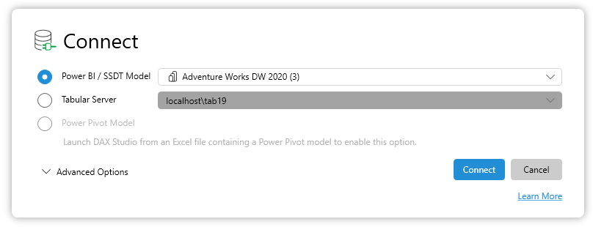
Connecting to SSDT (SQL Server Developer Tools)​
The SSDT option works if you are using the internal workspace option. In this scenario SSDT is similar to Power BI Desktop in that it launches a private version of the tabular engine in the background which we can then connect to. The only main difference between SSDT and Power BI Desktop is that we can only "see" the solution name, not the project name. So if you have multiple tabular models in a single solution you will see multiple entries with the same name, one for each project in the solution.
Connecting to Analysis Services​
To connect to an Analysis Services instance you just need to enter the instance name in the server option in the connection dialog
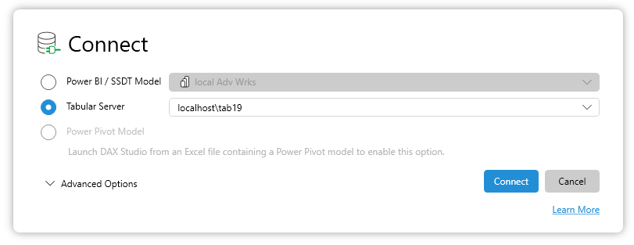
Connecting to Azure Analysis Services​
To connect to Azure Analysis Services you enter the name of your instance in the server option in the connection dialog. This typically is a string starting with asazure://
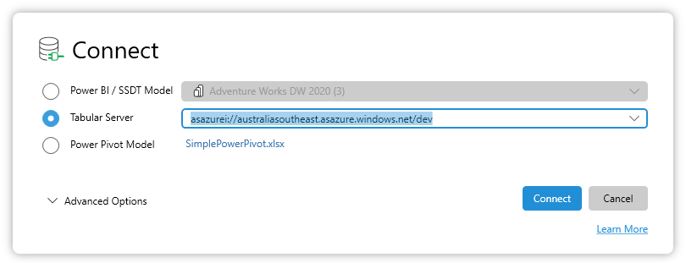

Basic Queries​
The simplest form of DAX query is EVALUATE <table expression>

So you can run EVALUATE Customer to output all the rows in the customer table
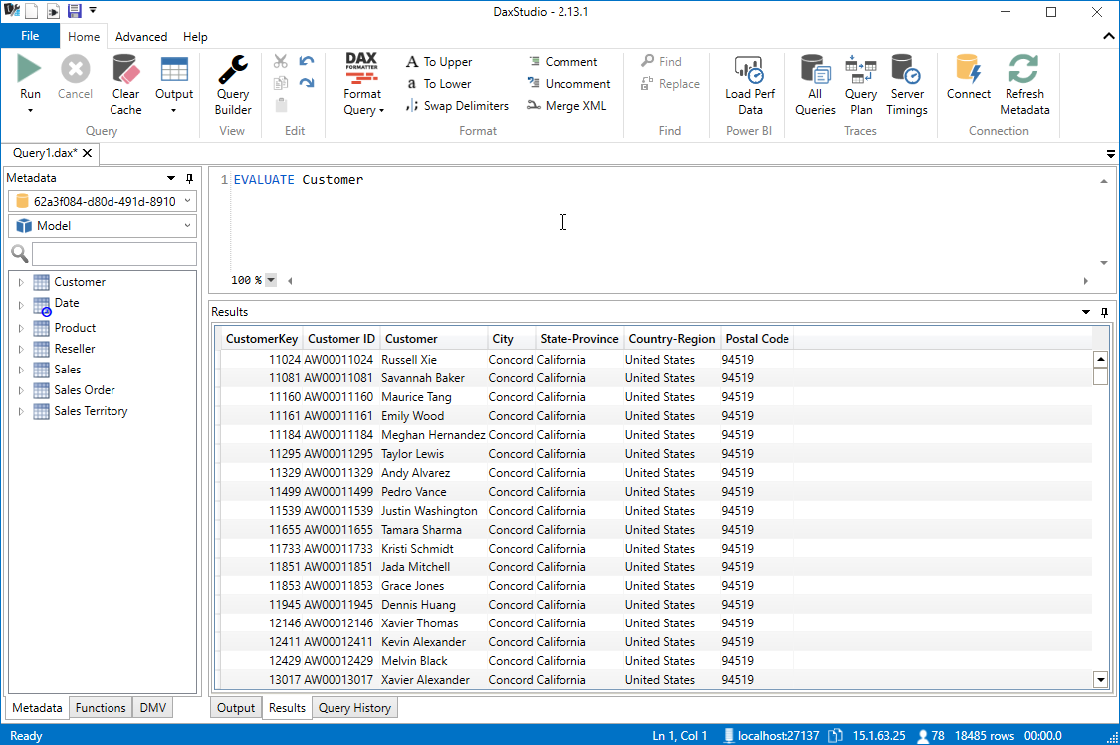
But you don't just have to use a table name, you can use any function that returns a table. To get a distinct list of all the values in a column you can use the VALUES function which returns a table with a single column with all the unique values from the specified column.

EVALUATE VALUES ( Customer[City] ) returns column, værdier fra Customer[City]
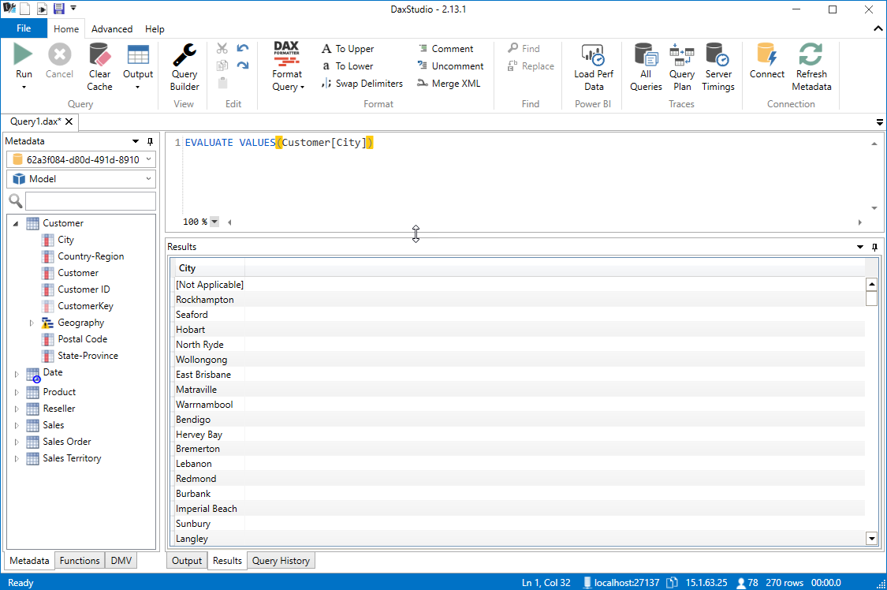
Or if you don't want every row in the table you could

CALCULATETABLE() , use to only return rows that meet a given criteria.
CALCULATETABLE(<table-expression>[, <filter1> [, <filter2> [, …]]])
Function | Purpose
REMOVEFILTERS | Remove all filters, or filters from one or more columns of a table, or from all columns of a single table.
ALL ¹, ALLEXCEPT, ALLNOBLANKROW | Remove filters from one or more columns, or from all columns of a single table.
KEEPFILTERS | Add filter without removing existing filters on the same columns.
USERELATIONSHIP | Engage an inactive relationship between related columns, in which case the active relationship will automatically become inactive.
CROSSFILTER | Modify filter direction (from both to single, or from single to both) or disable a relationship.
¹ The ALL function and its variants behave as both filter modifiers and as functions that return table objects. If the REMOVEFILTERS function is supported by your tool, it's better to use it to remove filters.

Return value :A table of values

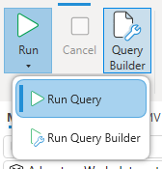
Run Query​
This is the default mode. It will execute the selected query and sent the results to the selected output

EVALUATE
CALCULATETABLE ( Customer, Customer[City] = "Redmond" )
EVALUATE
CALCULATETABLE ( sales, sales[LocationID] = 568)
You can even combine the VALUES and CALCULATETABLE functions to get a list of all Cities that have a first character of "R"
EVALUATE
CALCULATETABLE ( VALUES ( Customer[City] ), LEFT ( Customer[City], 1 ) = "R" )
// udfører filteret, der promptes for Color, her kan Red bruges
EVALUATE FILTER('product', 'product'[Color]=@myColor && 'product'[Category]="Bikes")

DATATABLE Function in DAX : a way to declare an inline set of data values

The DATATABLE function in DAX (Data Analysis Expressions) provides a way to declare an inline set of data values directly within your DAX expressions. This function is particularly useful when you need to create a small table of data without importing it from an external source.
Syntax
The syntax for the DATATABLE function is as follows:
DATATABLE (ColumnName1, DataType1, ColumnName2, DataType2..., {{Value1, Value2...}, {ValueN, ValueN+1...}...})
- ColumnName: The name of the column.
- DataType: The data type of the column, which can be INTEGER, DOUBLE, STRING, BOOLEAN, CURRENCY, or DATETIME.
- Value: A set of data values for the table, represented as an array of arrays.

DEFINE VAR VarName=..
DEFINE
VAR SelectedColors =
FILTER (
ALL ( 'Product'[Color] ),
'Product'[Color] IN { "Purple", "Azure" }
)

EVALUATE
CALCULATETABLE (
'Product',
SelectedColors
)

define
var tab=selectcolumns(Sales,"Quantity",Sales[Order Quantity],"UnitPrice",Sales[Unit Price],"ProductKey",
Sales[ProductKey],"Sales Amount",Sales[Sales Amount],"OrderDateKey",Sales[OrderDateKey])
evaluate topN(10,tab)
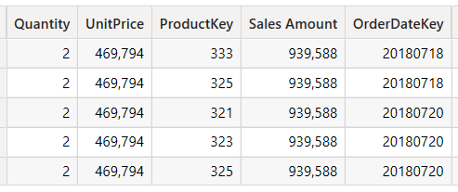..10 rækker

SELECTCOLUMNS(<Table>, [<Name>], <Expression>, [<Name>], …)
Smaller table = SELECTCOLUMNS(Table1;”This day revenue”;[Revenue])

CALCULATE(<expression>[, <filter1> [, <filter2> [, …]]])
Evaluates an expression in a modified filter context.
//virker ikke i studio
Sales_2018_2019 =
calculate(SUM('Sales'[Sales Amount]);'Date2'[Fiscal Year] in {"FY2018";"FY2019"} ) // tryk new measure

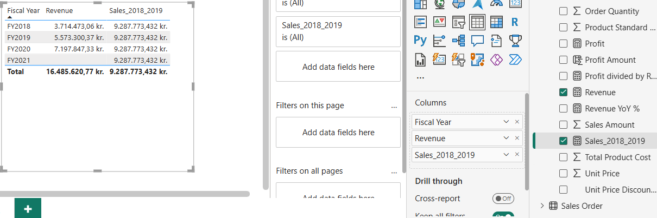

TREATAS meget stærkt værktøj
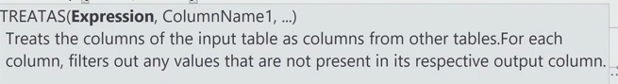

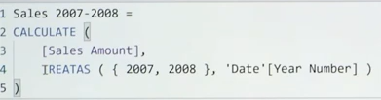
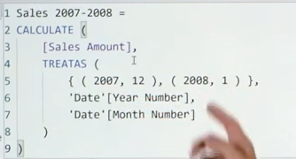for dec-2007 el. Jan-2008

Sorting Results​
If we continue on with the previous example you will see that the results come back in a random order. If we want our query to sort the results we can add an optional ORDER BY clause to the end of the query. So if we wanted to sort the results by the city name we would do the following:
EVALUATE
CALCULATETABLE ( VALUES ( Customer[City] ), LEFT ( Customer[City], 1 ) = "R" )
ORDER BY Customer[City]
NOTE: Some client tools (like Power BI Desktop) will generate an ORDER BY clause for you based on the properties set in your data model

Adding Calculations​, a measure
To add a calculation to your query like measures and variables you would use the optional DEFINE keyword at the start of your query
To define a new measure in your query which sums the value of the existing Sales[Sales Amount] column you would write the following:

DEFINE
MEASURE Sales[My Sales Amount] =
SUM ( Sales[Sales Amount] )

Aggregering over month, som tabeludtræk vha Revenue-measure, implicit tabel-join
EVALUATE
ADDCOLUMNS ( VALUES ( 'Date'[Month] ) , "My Sales Amount-navnet", [My Sales Amount] ) , eller
EVALUATE
ADDCOLUMNS ( VALUES ( 'Date'[Month] ) , "Revenue", [Revenue] )
Til VALUES ( 'Date'[Month])-kolonnen tllføjes kolonne "Revenue" ->[Revenue]
VALUES ( 'Date'[Month] )=datakilden=kolonnen
Sales_monthly= ADDCOLUMNS ( VALUES ( 'Date'[Month] ) , "Revenue", [Revenue] ) // i PBI: Model/new Table -> table med to kolonner oprettes!

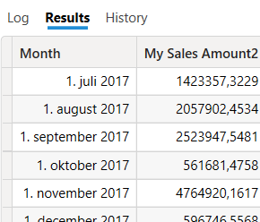..
To define multiple measures you can add multiple blocks of MEASURE <table>[<measure name>] = <expression>
DEFINE
MEASURE Sales[My Sales Amount] =
SUM ( Sales[Sales Amount] )
MEASURE Sales[My Double Sales Amount] =
SUM ( Sales[Sales Amount] ) * 2
EVALUATE
ADDCOLUMNS (
VALUES ( 'Date'[Month] ),
"My Sales Amount", [My Sales Amount],
"My Double Sales Amount", [My Double Sales Amount]
)
table med 3 kolonner
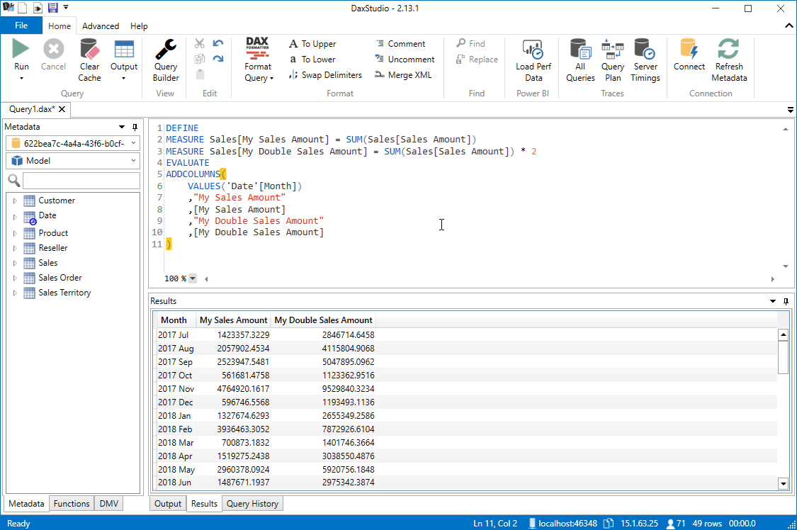

Returning a single value​
Sometimes you may just want to return the result of a measure. But measures return a single scalar value not a table, so if you try to write the following
EVALUATE
SUM ( Sales[Sales Amount] )
- it will produce a syntax error

We can fix this by using the table constructor syntax and wrapping the measure in curly braces { }
EVALUATE
{ SUM ( Sales[Sales Amount] ) }
For older versions of the tabular engine which do not support the table constructor syntax we can use the ROW function
EVALUATE
ROW ( "Sales Amount", [Sales Amount] )
You can also mix this with the DEFINE clause to create a measure expression and then return a single value
DEFINE
MEASURE Sales[Total Sales] =
SUM ( Sales[Sales Amount] )
EVALUATE
{ [Total Sales] }

SUMX(ColumnName) og SUM(Table,expression(row))
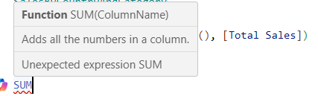
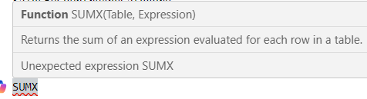

Selecting columns from multiple tables​, med implicit join
The easiest way to generate a query using columns from multiple tables is to use the SUMMARIZECOLUMNS function. This function takes a list of columns, followed by an optional list of table expressions to use as filters, followed by an optional list of measures/expressions.
De to tabeller joines automatisk via modellens realtioner
NOTE: It is strongly recommended to always use a measure or expression of some sort with the SUMMARIZECOLUMNS function if you don't do this the function will generate a large crossjoin of all possible combinations of every value in the specified columns which is not normally useful
EVALUATE
SUMMARIZECOLUMNS (
Product[Color],
Reseller[Business Type],
FILTER ( ALL ( 'Product'[List Price] ), 'Product'[List Price] > 150.00 ),
TREATAS ( { "Accessories", "Bikes" }, 'Product'[Category] ),
"Total Sales", SUM ( Sales[Sales Amount] )
)
To filtrer her: 'Product'[List Price] > 150.00 og 'Product'[Category] in { "Accessories", "Bikes"}
//Sales and Date joines implicit: finder salg/år
EVALUATE
ADDCOLUMNS (
SUMMARIZE (
Sales,
'Date'[Fiscal Year],
Product[Color]
),
"Total Quantity", CALCULATE ( SUM ((sales[sales amount] ) ))
)

EVALUATE
SUMMARIZECOLUMNS (
Product[Color],
FILTER ( ALL ( 'Product'[List Price] ), 'Product'[List Price] > 150.00 ),
TREATAS ( { "Accessories", "Bikes" }, 'Product'[Category] ),
"Total Sales", SUM ( Sales[Sales Amount] )
)
Ser kun på 'Product'[Category] in ( { "Accessories", "Bikes" }
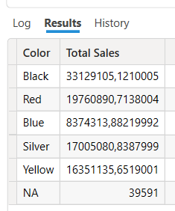

Multiple Resultsets​
DAX queries also allow for the return of multiple recordsets within a given batch
So you can execute the following:
EVALUATE
Customer
EVALUATE
'Product'
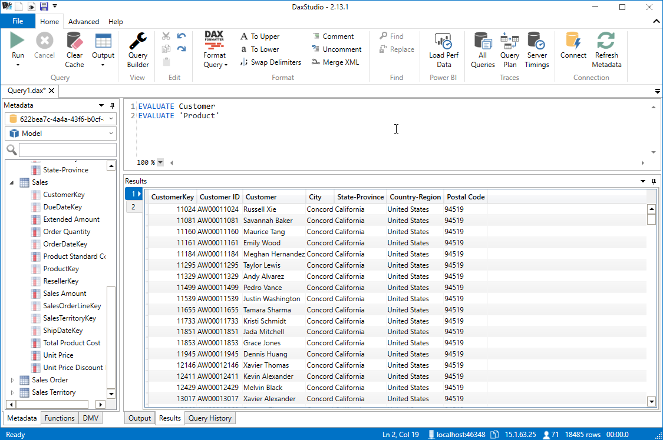
And you will get 2 tabs returned in DAX Studio, one with the contents of the Customer table and the other with the contents of the Product table.
But note that within a single batch, although you can have multiple EVALUATE statements you can only have a single DEFINE statement. So you would need to declare all your calculations in that one block.
DEFINE
MEASURE Sales[Total Sales] =
SUM ( Sales[Sales Amount] )
MEASURE Sales[Total Cost] =
SUMX ( Sales, Sales[Unit Price] * Sales[Order Quantity] )
EVALUATE
{ [Total Sales] }
EVALUATE
{ [Total Cost] }
109809274,202999
110336782,091399

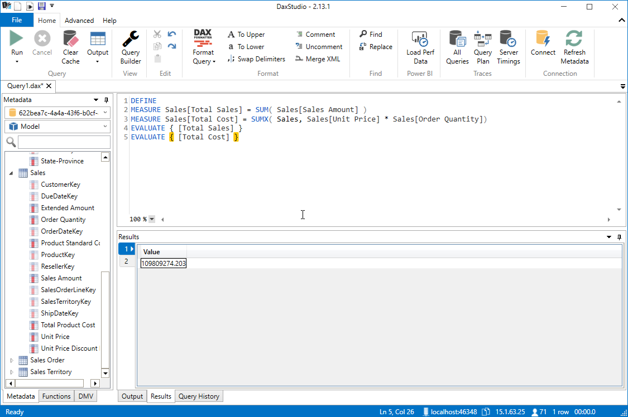

Using Parameters in Queries​
One of the unique features that DAX Studio has is the support for parameterized queries
To add a parameter to a DAX query you can start with a query that includes a filter such as the following:
EVALUATE
FILTER ( 'Product', 'Product'[Color] = "Red" )
And then replace the reference to "Red" with a parameter called @Color
EVALUATE
FILTER ( 'Product', 'Product'[Color] = @Color )
When you execute a query with a parameter, DAX Studio will prompt you for the parameter to use
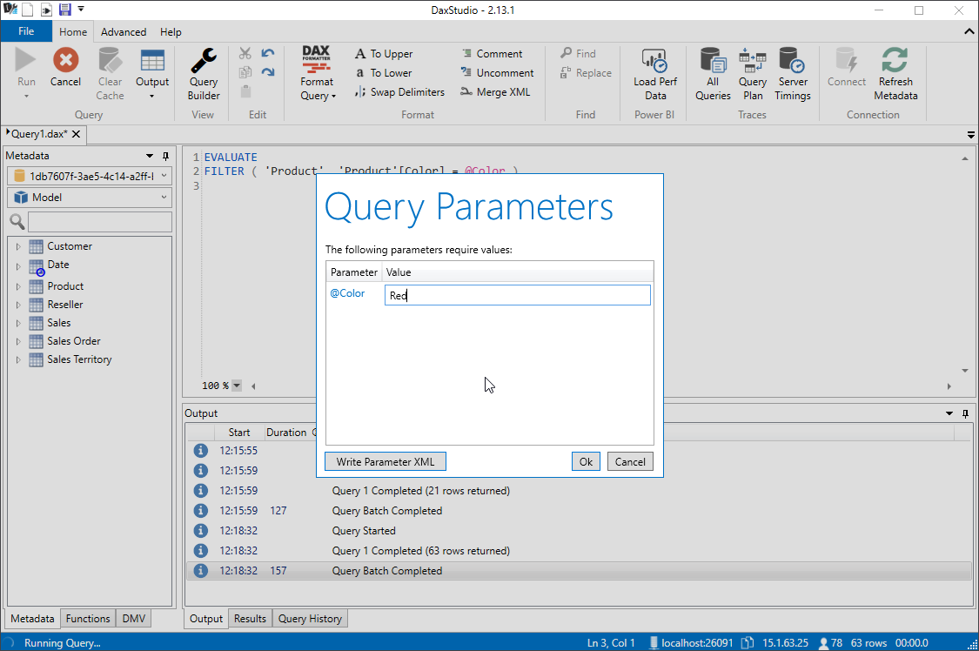

Previous

Web-course
https://campus.datacamp.com/courses/introduction-to-dax-in-power-bi/getting-started-with-dax?ex=1

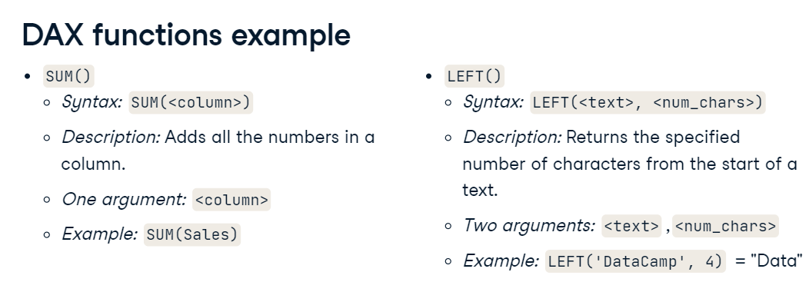

Create new column in table
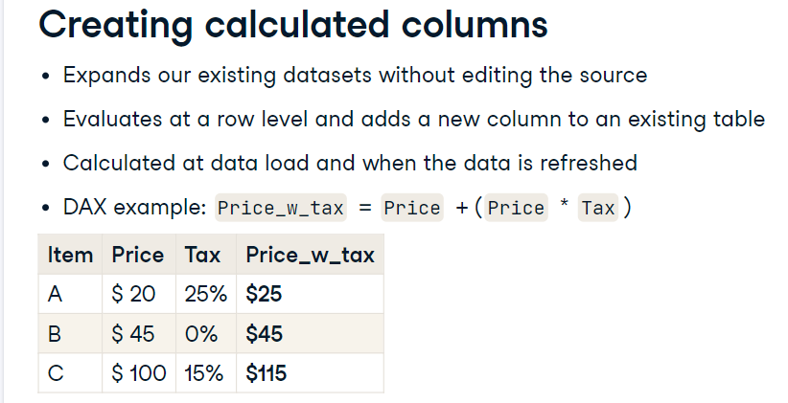
Column = Sales[Sales Amount]-Sales[Product Standard Cost]
Husk evaluate!
evaluate
ADDCOLUMNS(<table>, <name>, <expression>[, <name>, <expression>]…)

ADDCOLUMNS(Date,weekday, FORMAT('Date'[Date],"dddd"))
<name>, <expression>[, <name>, <expression>]…)

FORMAT('calendar'[Date],"dddd")

Parameters
Expand table
Term | Definition
table | Any DAX expression that returns a table of data.
name | The name given to the column, enclosed in double quotes.
expression | Any DAX expression that returns a scalar expression, evaluated for each row of table.
Return value
A table with all its original columns and the added ones.
Eks, der laves to kolonner:
ADDCOLUMNS(ProductCategory
, "Internet Sales", SUMX( RELATEDTABLE(InternetSales_USD), InternetSales_USD[SalesAmount_USD] )
, "Reseller Sales", SUMX(RELATEDTABLE(ResellerSales_USD), ResellerSales_USD[SalesAmount_USD]))
//sum over InternetSales_USD[SalesAmount_USD]-felterne via relationen
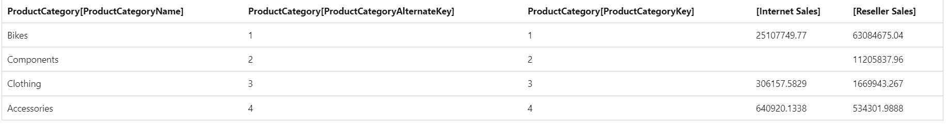
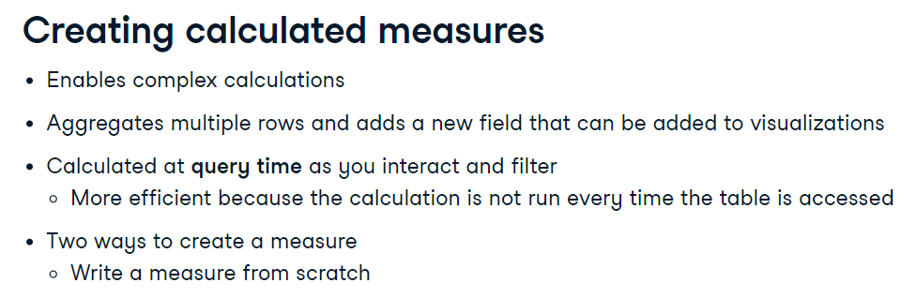
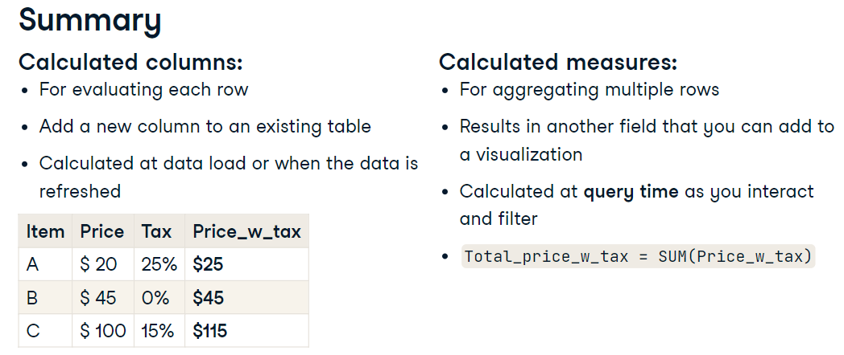

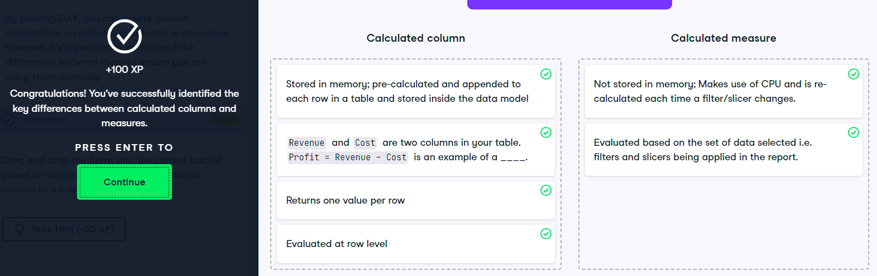

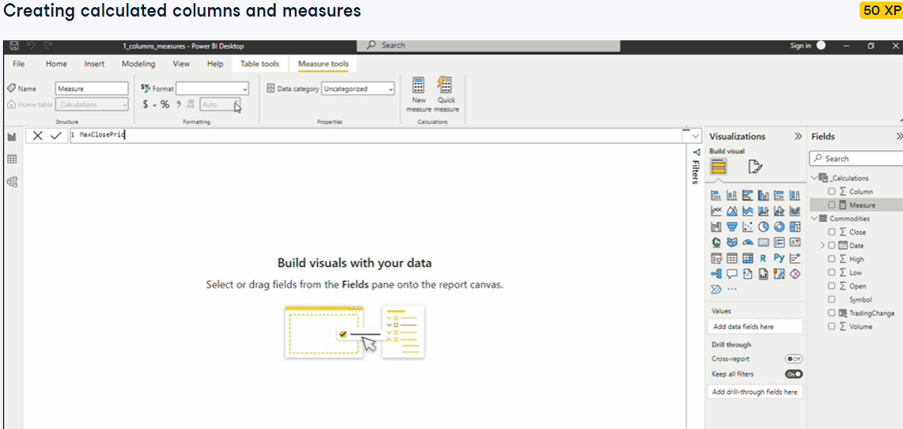
Godt at lave egentlig tabel ed measures samlet, _measure, så kommer den øverst

//sum af kolonne-værdier
EVALUATE
{SUM(Sales[Sales Amount])} //109809274,203
//udskriv measure-værdi
EVALUATE
{ [Total Cost] }
//virker i Studio
DEFINE
TABLE Sales3=
ADDCOLUMNS(Sales,
"Profit3", Sales[Sales Amount] -Sales[Total Product Cost])
//men kan ikke exportere den nye tabel,
//bedre lave ny nye kolonner i PBI, så udskrive disse fra Studio
//kan udskrives:
EVALUATE
TOPN(10, 'Sales3')

Lave permanent tabel, der tilføjes datamodellen:
//VIrKER I PBI, MEN IKKE i DAX-studio
Segments_Datatable2 =
DATATABLE (
"Price Range"; STRING;
"Min Price"; CURRENCY;
"Max Price"; CURRENCY;
{
{ "Low"; 0; 10};
{ "Medium"; 10; 100 };
{ "High"; 100; 9999999 }
}
)

https://www.sqlbi.com/articles/best-practices-using-summarize-and-addcolumns/

Extension Columns: columns that you add to existing tables
Extension columns are columns that you add to existing tables. You can obtain extension columns by using both ADDCOLUMNS and SUMMARIZE. For example, the following query adds an Open Year column to the rows returned from the Store table.
EVALUATE
SUMMARIZE (
Store,
Store[Country],
"Stores", COUNTROWS( Store )
)

Query Projection
In a SELECT statement in SQL, you can choose the column projected in the result, whereas in DAX you can only add columns to a table by creating extension columns. The only workaround available is to use SUMMARIZE to group the table by the columns you want to obtain in the output. As long as you do not need to see duplicated rows in the result, this solution does not have particular side effects. For example, if you want to get just the list of store names and their corresponding open date, you can write the following query.

EVALUATE
SUMMARIZE (
Store,
Store[Name],
Store[Open Date]
)
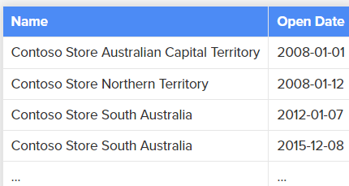
You can also create an extension column by using SUMMARIZE. For example, you can count the number of stores for each country by using the following query (please note that this query is not a best practice – you will see why later in this article).

SUMMARIZE=laver grupperinger
SUMMARIZE ( <Table> [, <GroupBy_ColumnName> [, [<Name>] [, [<Expression>] [, <GroupBy_ColumnName> [, [<
EVALUATE
SUMMARIZE (
Store,
Store[Country],
"Stores", COUNTROWS( Store )

EVALUATE
SUMMARIZE (
Store,
Store[Name],
Store[Open Date],
"Open Year", YEAR ( Store[Open Date] )
)
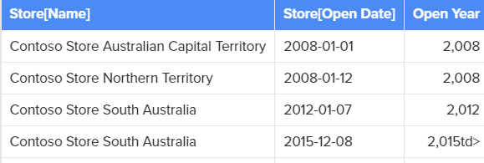

Addcolumns med summerize giver aggregeringer
EVALUATE
ADDCOLUMNS (
SUMMARIZE (
Store,
Store[Name],
Store[Open Date]
),
"Open Year", YEAR ( Store[Open Date] )
)
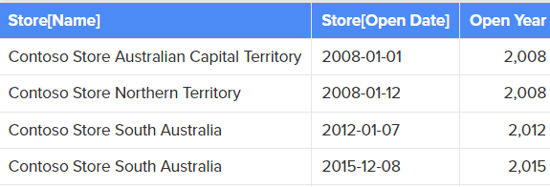
Evaluate // skal med!
ADDCOLUMNS(<table>, <name>, <expression>[, <name>, <expression>]…)

Both queries above produce the same result.
However, you should always favor the ADDCOLUMNS version. The rule of thumb is that you should never add extended columns by using SUMMARIZE, unless it is required due to at least one of the following conditions:
- You want to use ROLLUP over one or more grouping columns in order to obtain subtotals
- You are using non-trivial table expressions in the extended column, as you will see in the “Filter Context in SUMMARIZE and ADDCOLUMNS” section later in this article
The best practice is that, whenever possible, instead of writing
SUMMARIZE( <table>, <group_by_column>, <column_name>, <expression> )

you should write:
ADDCOLUMNS(
SUMMARIZE( <table>, <group by column> ),
<column_name>, CALCULATE( <expression> )
)
The CALCULATE you can see in the best practices template above is not always required, but you need it whenever the <expression> contains an aggregation function. The reason is that ADDCOLUMNS operates in a row context that does not automatically propagate into a filter context, whereas the same <expression> within a SUMMARIZE is executed into a filter context corresponding to the values in the grouped columns. The previous examples used a scalar expression over a column that was included in the SUMMARIZE output, so the reference to the column value was valid within the row context. Now, consider the following query that you have already seen at the beginning of this article.

Aggregeringer over grupper
//aggr over hvert år
EVALUATE
ADDCOLUMNS (
SUMMARIZE (
Sales,
'Date'[Fiscal Year]
),
"Total Quantity", CALCULATE ( SUM ((sales[sales amount] ) ))
)
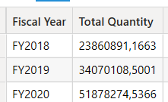
Date2 =ADDCOLUMNS(Date,"Weekday", WEEKDAY('Date'[Full Date], 2) ) //duer ikke
// kan lave permanent Date2 med denne kolonne tilføjet Date i pbi, så kommer den automatisk ind her i studio, husk relation i datamodel
// agg efter 7 ugedage
EVALUATE
topn(10,
ADDCOLUMNS (
SUMMARIZE (
Sales,
'Date2'[Weekday]
),
"Total Quantity", CALCULATE ( SUM ((sales[sales amount] ) ))
)
)

SUMMARIZECOLUMNS er generelt mere effektiv end SUMMARIZE+AddColumns
SUMMARIZECOLUMNS( <groupBy_columnName> [, < groupBy_columnName >]…, [<filterTable>]…[, <name>, <expression>]…) er bedre end SUMMARIZE+AddColumns
SUMMARIZECOLUMNS (
'Sales Territory'[Category],
FILTER('Customer', 'Customer' [First Name] = "Alicia")
)
In this query, without a measure the groupBy columns do not contain any columns from the FILTER expression (for example, from Customer table). The filter is not applied to the groupBy columns. The Sales Territory and Customer tables may be indirectly related through the Reseller sales fact table. Since they're not directly related, the filter expression is a no-op, altså ingen effect, and the groupBy columns are not impacted.
However, with this query:
SUMMARIZECOLUMNS (
'Sales Territory'[Category], 'Customer' [Education],
FILTER('Customer', 'Customer'[First Name] = "Alicia")
)
The groupBy columns contain a column, 'Customer' [Education], which is impacted by the filter and that filter is applied to the groupBy results.
evaluate
SUMMARIZECOLUMNS (
'Sales'[Sales Amount], 'Product'[Category],'Product'[Product],Sales[ProductKey],'Product'[ProductKey],
FILTER('Product', 'Product'[Category] = "Bikes")
)
ORDER BY 'Product'[Product] duer ikke
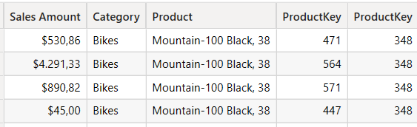

evaluate
SUMMARIZECOLUMNS (
'Sales'[Sales Amount], 'Product'[Category],'Product'[Product],Sales[ProductKey],'Product'[ProductKey],
FILTER('Product', 'Product'[Category] = "Bikes") ,
Sales //!
)
ORDER BY 'Product'[Product]
//1603 rows, ok

For example, consider the following syntax:
1  2  3  4  5 | Sales by Year and Color crossjoin implicit =  SUMMARIZECOLUMNS (  'Date'[Calendar Year],  'Product'[Color]  )
CopyConventions#5

It produces all the possible combinations between year and color, which are 112 in our example (7 years multiplied by 16 colors), and it corresponds to the following query:
1  2  3  4  5 | Sales by Year and Color crossjoin explicit =  CROSSJOIN (  VALUES ( 'Date'[Calendar Year] ),  VALUES ( 'Product'[Color] )  )
CopyConventions#6

What is the equivalent syntax of this SUMMARIZE that returns only the existing 47 combinations of year and color used by at least one row of the Sales table? It is the following one:
1  2  3  4  5  6 | Sales by Year and Color summarize =  SUMMARIZE (  Sales,  'Date'[Calendar Year],  'Product'[Color]  )
CopyConventions#7

You must specify the optional filter table argument after the columns you aggregate, and before any additional calculated column (not present in this case):
1  2  3  4  5  6 | Sales by Year and Color summarizecolumns =  SUMMARIZECOLUMNS (  'Date'[Calendar Year],  'Product'[Color],  Sales

GROUPBY
GROUPBY (<table> [, <groupBy_columnName> [, <groupBy_columnName> [, …]]] [, <name>, <expression> [, <name>, <expression> [, …]]])

Remarks
- The GROUPBY function does the following:
  - Start with the specified table (and all related tables in the "to-one" direction).
  - Create a grouping using all of the GroupBy columns (which are required to exist in the table from step #1.).
  - Each group is one row in the result, but represents a set of rows in the original table.
  - For each group, evaluate the extension columns being added. Unlike the SUMMARIZE function, an implied CALCULATE is not performed, and the group isn't placed into the filter context.
- Each column for which you define a name must have a corresponding expression; otherwise, an error is returned. The first argument, name, defines the name of the column in the results. The second argument, expression, defines the calculation performed to obtain the value for each row in that column.
- groupBy_columnName must be either in table or in a related table.
- Each name must be enclosed in double quotation marks.
- The function groups a selected set of rows into a set of summary rows by the values of one or more groupBy_columnName columns. One row is returned for each group, i eksemplet for hver Country
- GROUPBY is primarily used to perform aggregations over intermediate results from DAX table expressions. For efficient aggregations over physical tables in the model, consider using SUMMARIZECOLUMNS or SUMMARIZE function.
- This function is not supported for use in DirectQuery mode when used in calculated columns or row-level security (RLS) rules.
With CURRENTGROUP
CURRENTGROUP can only be used in an expression that defines an extension column within the GROUPBY function. In-effect, CURRENTGROUP returns a set of rows from the table argument of GROUPBY that belong to the current row of the GROUPBY result. The CURRENTGROUP function takes no arguments and is only supported as the first argument to one of the following aggregation functions: AVERAGEX, COUNTAX, COUNTX, GEOMEANX, MAXX, MINX, PRODUCTX, STDEVX.S, STDEVX.P, SUMX, VARX.S, VARX.P.
Example
The following example first calculates the total sales grouped by country and product category over physical tables by using the SUMMARIZECOLUMNS function. It then uses the GROUPBY function to scan the intermediate result from the first step to find the maximum sales in each country across the product categories.

//grouppering
DEFINE
VAR SalesByCountryAndCategory =
SUMMARIZECOLUMNS(
'Sales Territory'[Country],
Product[Category],
"Total Sales", SUMX(Sales, Sales[Unit Price] * Sales[Order Quantity])
)
EVALUATE SalesByCountryAndCategory
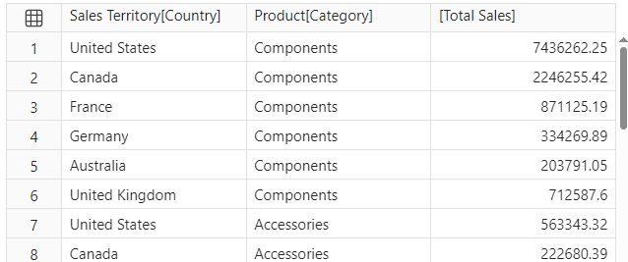24 rækker

Samlet, først intermediate gruppering, dernæst en aggrering over intermediate gruppering
DEFINE
VAR SalesByCountryAndCategory =
SUMMARIZECOLUMNS(
'Sales Territory'[Country],
Product[Category],
"Total Sales", SUMX(Sales, Sales[Unit Price] * Sales[Order Quantity])
)
//EVALUATE SalesByCountryAndCategory
EVALUATE
GROUPBY(
SalesByCountryAndCategory,
'Sales Territory'[Country],
"Max Sales", MAXX(CURRENTGROUP(), [Total Sales])
)
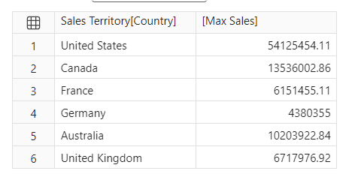
SUMMARIZE function SUMMARIZECOLUMNS function

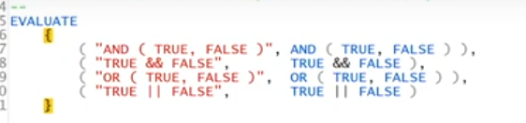
And(True, false) And operatoren med argumenter -> True and False ->false
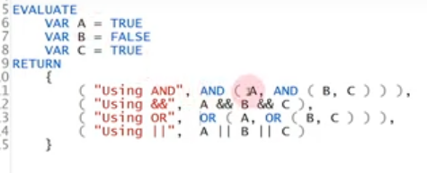

Calculate table
//make calcualted table, testing, så kopier koden ind i PBI, med Model/new table; table oprettes så
EVALUATE
SUMMARIZECOLUMNS (
'Product'[Category],
'Product'[subCategory],
"sales", [Revenue]
)

Udskrive til CVS-fil
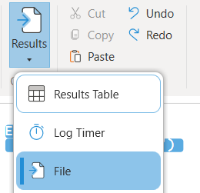

Export datamodel til SQL
https://daxstudio.org/docs/features/command-line/commands/export-sql-command/
Examples
The following example exports all of the tables from the Adventure Works model

dscmd.exe export sql "Data Source=localhost\sql;Initial Catalog=DataDump;Integrated Security=SSPI" -s localhost\tabular -d "Adventure Works"

The following example exports only exports the Product, Product Category and Reseller Sales tables from the Adventure Works model

dscmd.exe export sql "Data Source=localhost\sql;Initial Catalog=DataDump;Integrated Security=SSPI" -s localhost\tabular -d "Adventure Works" -t Product "Product Category" "Reseller Sales"
Adventure Works DW 2020 M04
"C:\Program Files\DAX Studio\DaxStudio.exe"
C:\Program Files\DAX Studio\
EVALUATE FILTER('product', 'product[Color]=@myColor && 'product'[Category]=@myCategory) udskriver tabel, der promptes for Color, Category
Der opstår fejl I alle tilfælde:
C:\Program Files\DAX Studio\dscmd xlsx c:\temp\myquery.xlsx -s localhost\tab19 -d "Adventure Works DW 2020 M04" ^
-m myColor=Red ^
-m myCategory=Bikes ^
-q "EVALUATE FILTER('product', 'product[Color]=@myColor && 'product'[Category]=@myCategory)
C:\Program Files\DAX Studio\dscmd xlsx myquery.xlsx -s localhost\tab19 -d "Adventure Works DW 2020 M04" ^
-m myColor=Red ^
-m myCategory=Bikes ^
-q "EVALUATE FILTER('product', 'product'[Color]=@myColor && 'product'[Category]=@myCategory)
dscmd xlsx myquery.xlsx -s localhost -d "Adventure Works DW 2020 M04" ^
-m myColor=Red ^
-m myCategory=Bikes ^
-q "EVALUATE FILTER('product', 'product'[Color]=@myColor && 'product'[Category]=@myCategory)
dscmd xlsx myquery.xlsx -s localhost -d "Adventure Works DW 2020 M04" ^
-m myColor="Red" ^
-m myCategory="Bikes" ^
-q "EVALUATE FILTER('product', 'product'[Color]=@myColor && 'product'[Category]=@myCategory)

Udskrive liste over measures
//viser alle measures
select * from $system.mdschema_measures
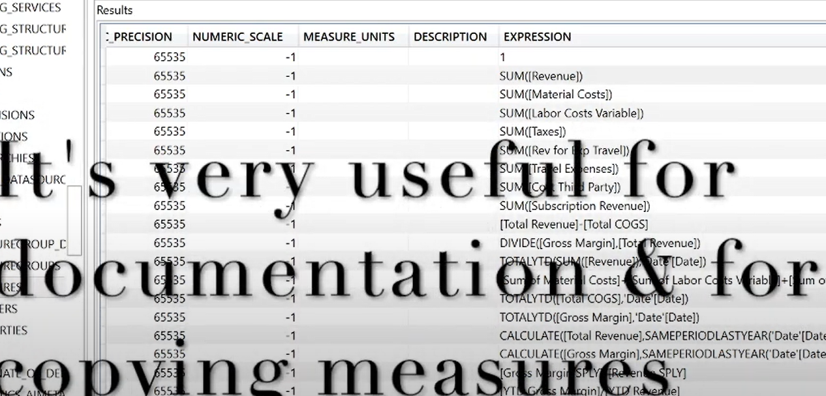

Udskrive metrikker
Vertipaq analyser
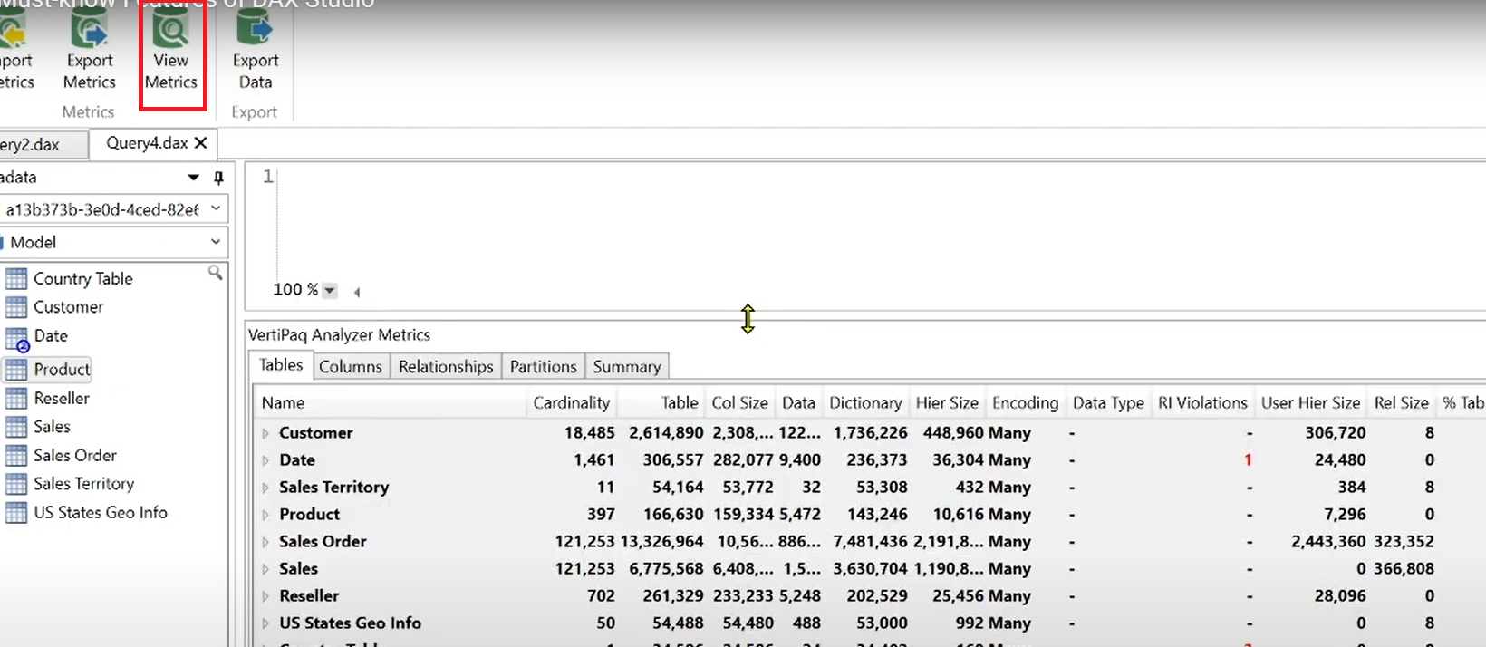

Metrikken kan exporters til eventual support, som .vpax fil

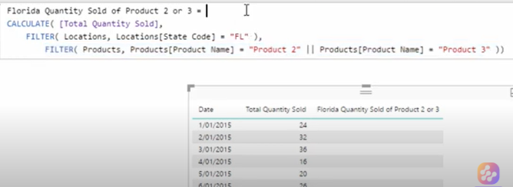
Kan erstattes med hjælpsomme forklarende variable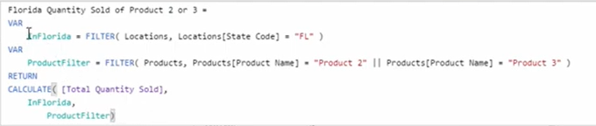
..

EVALUATEANDLOG() KAN give indsigt, men virker ikke
The EVALUATEANDLOG() function is only enabled in Power BI Desktop, in order for it to work it sometimes has to disable some internal engine optimizations. DAX Studio is aware of this and will only enable the trace button when you are connected to a model hosted in Power BI Desktop
DEFINE
MEASURE Sales[Measure1] =
EVALUATEANDLOG ( COUNT ( 'Product'[ProductKey] ), "Measure1" )
EVALUATE
{ [Measure1] }
Der åbnes ingen log !?
The User Interface​
- EvaluateAndLog calls from your query are captured and displayed in the list on the left. A single query can have multiple calls to EVALUATEANDLOG()
- The expression for the currently selected trace event is show here
- Columns with a Blue underline are input columns generated by the current filter context
- Columns with a Yellow underline are output columns
- The remain columns are metadata columns show the table number, row number and total count of rows in the result
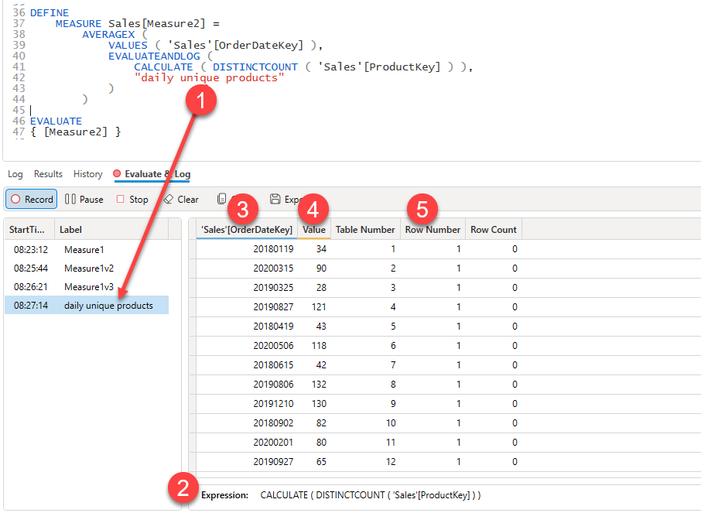
Learn More​
The EvaluateAndLog tutorial has a number of examples showing how this feature can be used to gain more insights into your query evaluations.

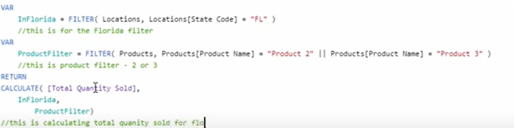

Measure information,
venstreklik til vælg, så højreklik
